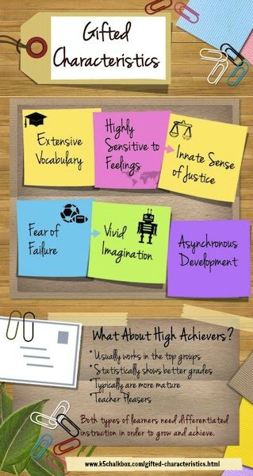

**==========**

**Questions? Concerns? Comments?**

**Contact: Amy Blackard**

**Program Coordinator**

[**amy.blackard@csdar.org**](mailto:amy.blackard@csdar.org)

**Clarksville**

**Identified LIGHTS**



**L**earning

**I**ndependently and

**G**aining

**H**igher

**T**hinking

**S**kills

**Elements of the Program**

**Creativity**

**Problem-Solving**

**Independent Study**

**Communication Skills**

**Personal Growth**

**(Affective)**

[**http://clarksvillegt.weebly.com/**](http://clarksvillegt.weebly.com/)

Content-What is being learned?

* Focus on complex and abstract ideas
* Study the practices/methods of inquiry used by scholars and experts
* Include content areas not taught in the regular curriculum

Process-How is material learned?

* Emphasis on critical thinking skills
* Explanations for reasoning used to reach conclusions
* Discovery approach to learning
* Opportunity to investigate areas of interest
* Provide small group activities to develop social/leadership skills
* Provide for the development of creative thinking skills, decision-making, and communication skills

Product-Results from the learning

* Produce a product to reflect learning
* Show the results of an investigation by sharing with an audience
* Evaluation made of product by self, peers, and other audiences



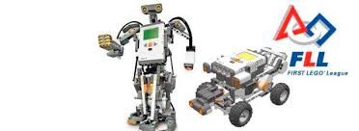

**-Program Objectives-**

* Focus on STEM skills
* Investigate real-world challenges
* Apply real-world math and science concepts
* Learn critical thinking, team-building and presentation skills
* Explore subjects through content, process, and product
* Discover career possibilities
* Connect with experts in their fields of study



**Identification**

* Clarksville currently serves 106 gifted students in grades 3-12.
* Referrals may be made at any time for grade 3-12 students.
* Parents, teachers, community members, and students may refer students for testing.
* Identification committee evaluates data to determine if placement in the gifted program is needed.
* Junior high and high school students continue to be served by gifted specialists.

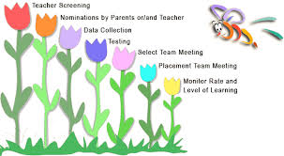

**What is LIGHTS?**

LIGHTS is a gifted education program offered to identified gifted students in the 3rd – 6th grades.

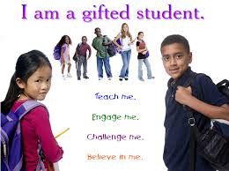

**Philosophy**

* Long history of commitment to excellence
* Entails helping every student meet his/her potential
* Recognizes and supports the concept of differentiated curriculum
* Provides for the needs of gifted and talented students

**Clarksville School District Gifted and Talented Staff**

Amy Blackard, Kraus Specialist and District Coordinator

Sharla Fultz, Pyron Specialist

Patricia Tucker, Primary Specialist