Identification Procedures and Practices

The Clarksville School District contends that the appraisal of any student is a serious matter, and that it is best accomplished by following guidelines to insure the rights of each student. The following procedures will be followed in the identification of potential Identified LIGHTS’ students.

- All data collected on students will be in conformity with special education standards in regards to confidentiality.
- Written consent must be obtained from parents or legal guardians if individual tests are administered. A letter describing the purpose of assessment procedures and the right to review information concerning test data must accompany the testing permission forms.
- A special effort, through the use of multi-identification methods, will be made to identify students with characteristics which make them difficult to identify such as:
  - Minority groups
  - Underachievers
  - Culturally different or economically disadvantaged
  - Highly creative thinkers
  - Highly intellectually gifted
- Identification will be based on multiple and specific criteria which includes both objective and subjective information.
- All certified staff will be informed of the characteristics of gifted students and the identification procedures in both oral and written form.
- Permission must be obtained from parents or legal guardians for students to participate in Identified LIGHTS.
- If requested, individual consultation on identification procedures and the results will be provided to parents or legal guardians and students.
- Identification procedures have been based on our local definition of gifted and have evolved from the philosophy, goals, and objectives established and updated by the Placement Committee and Advisory Committee.
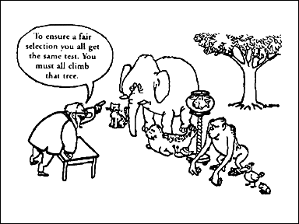
- The identification procedures are compatible with the definition of giftedness and comply with the Guidelines of the Arkansas Department of Education.

- The Placement Committee will be composed of professionally qualified persons, including, but not limited to: an administrator, two classroom teachers, or one from each grade level or content area being considered, GT personnel, and a counselor, if available.
- District-wide identification will be carried out in the spring, but new students, or a student for which new data has been collected, may be considered for and placed in the program at any time during the school year.
- Staff or parents/legal guardians may appeal the decision of the Placement Committee by asking for and following the Appeals Procedure.

